#### CISM314 PRACTICAL

#### RAMADIE 0 27543404

#### JOHNSON TK 27353362

#### TLAPE K 27693988

#### LAB4: PARSING AND TRANSLATING BINARY EXPRESSIONS

Aim: Pass and translate general expressions that involve addition and subtraction. Provide the correct assembly for translating binary expressions for example “**1 + 2**” or “**5 - 3**”.

Parsing digits and expressions enable communication with the I\O hence they are important aspect of compiler design. Parsing is referring to the reading of a program code. For example, once a program is written, the code requires to be parsed by the compiler in order to be compiled. Meanwhile translating is the converting of higher level code into another high-level code. It actually attain some level of code conversion to a specific objective language.

Sublime Text 3, where the code will be typed using pascal programming language and DOSBox, where we will compile and run our pascal code were downloaded.

We have a basic cradle.pas mini compiler program with a procedure enabling it to work with single digits and binary expressions such as “1 + 2” or “5 - 3”. The expression works with any number of term that is given to it without isolating it.

When the main cradle file was ran there was an error.

To fix this we need a procedure that recognizes a term and leaves its result somewhere, and another that recognizes and distinguishes between a '+' and a '-' and generates the appropriate code. But if Expression is going to leave its result in DO, Term leaves its result at the same place. We are going to have to save the first result of Term

somewhere before we get the next one.

A procedure Term was created and it does what Expression was doing before. So the procedure Expression was renamed to Term.

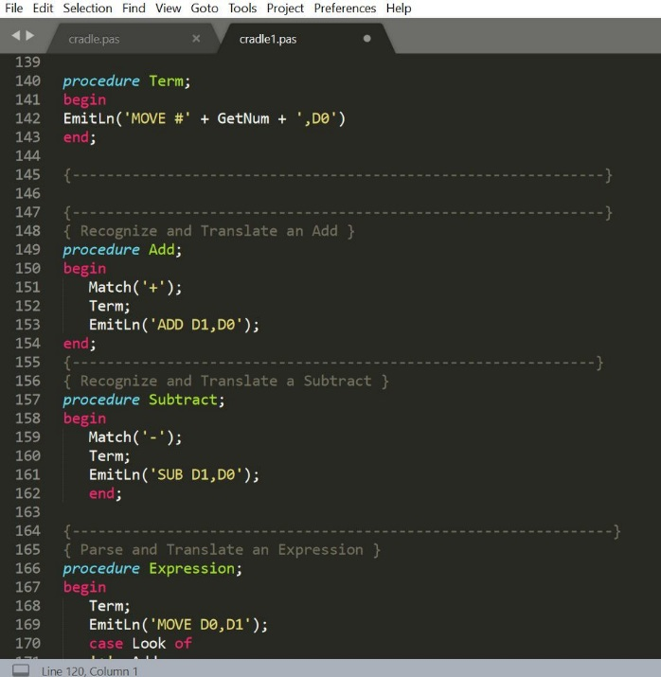

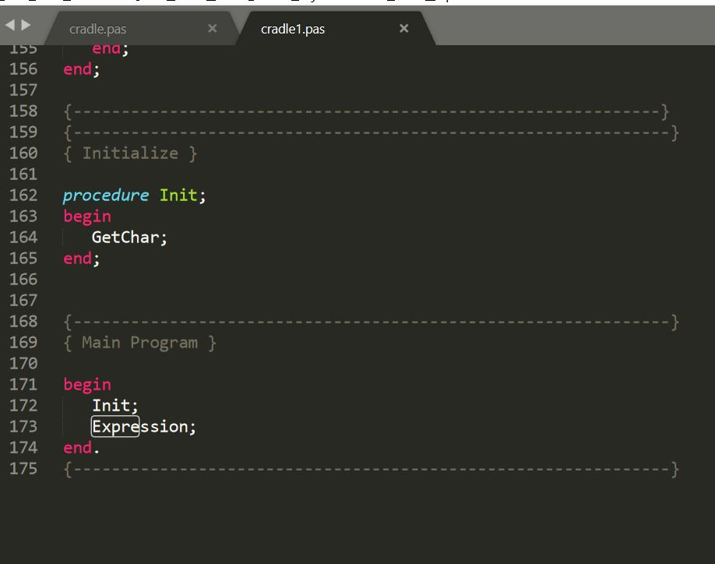

The order of the routines is: Term, Add, Subtract and Expression.

In conclusion, the program runs and produces the expected result. Figure 1, 2 and 3 below shows the results of the program when ran with expected inputs.

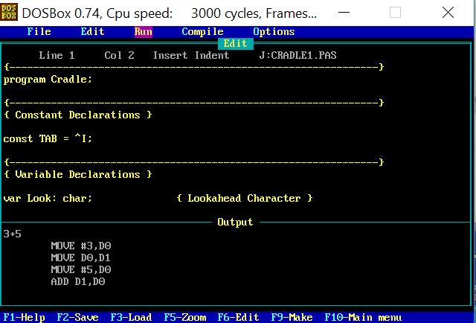

Figure 1

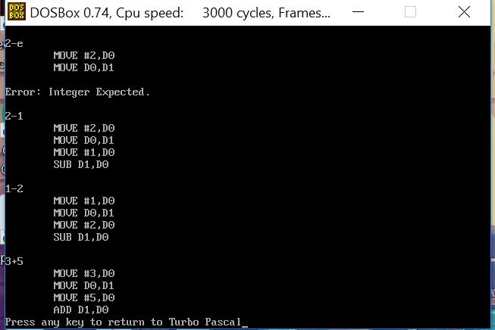

Figure 2

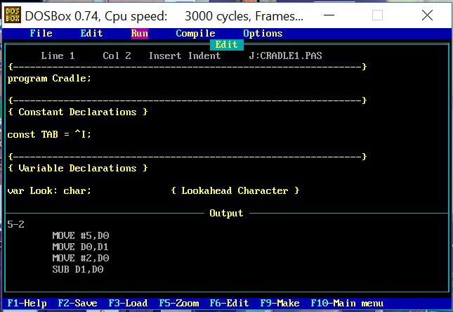

Figure 3

When we run the program and enter the incorrect inputs, it will say “Error: Integer Expect” thus indicating that it does not know what to do with the incorrect value.